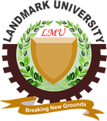

TECHNICAL REPORT ON STUDENT INDUSTRIAL TRAINING
WORK EXPERIENCE SCHEME (SIWES)

CONDUCTED BY EDET ANIEBIET INI-ABASI
2201376/22CD009337
THE DEPARTMENT OF COMPUTER SCIENCE
COLLEGE OF PURE AND APPLIED SCIENCES
LANDMARK UNIVERSITY OMURAN
KWARA STATE.
AT
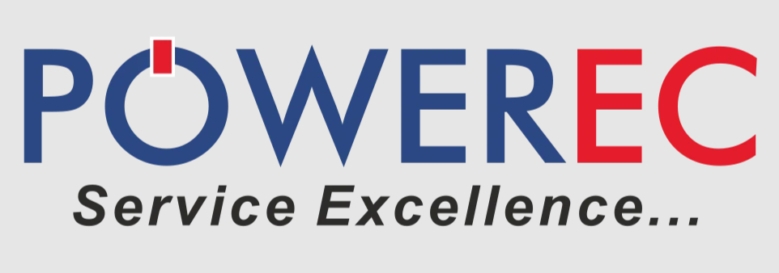
NOVEMBER, 2025
DECLARATION
I, EDET Aniebiet Ini-Abasi hereby declare that the SIWES Report has been carried out by me under the supervision of Mr ALFA PETER. It has not been presented for the award of any degree in any institution. All sources of information are specifically acknowledged by means of reference.
................................ .................................
Signature Date

CERTIFICATION
This SIWES Report by EDET Aniebiet Ini-Abasi meets the requirements governing the award of the degree of Bachelor of Science in Computer Science and is approved for its contribution to knowledge and literary presentation.
……………........ ………………
Mr. Alfa Peter Date (Supervisor)
…………........ …………………. Mr Oluwe Oluwambo Date (Dept. SIWES Officer)
…………........ ……………….
Prof. Ayodele Adebiyi Date (Head of Department)

DEDICATION
This work is dedicated to the Almighty God, my uncle – Mr Enobong Inyang, my family, Mrs Deborah Babalola for her assistance in helping me secure a placement and my fellow students with whom I collaborated on projects together.

